2021 Rotary Honors Veterans Freedom Fun Run
Nov. 13, 2021
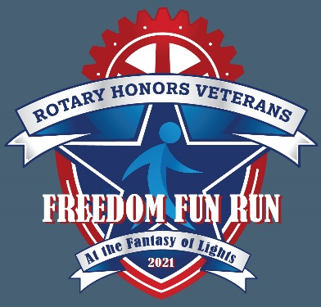

Sponsorship Level Opportunities

4-STAR – Freedom Fighter Sponsor – $2,500+
All 3-Star Patriotism Sponsor Benefits, PLUS
- Mentions in promotional announcements on media sponsor 104.9 FM The River radio station
- Acknowledgement in event announcements before and after the Freedom Fun Run at the staging and event sites
- Logo inclusion in graphics on Rotary website, email and social media posts before and after the
event

3-STAR – Patriotism Sponsor – $1,000+
All 2-Star Stars & Stripes Sponsor Benefits, PLUS
- Opportunity to place yard signs along the Freedom Fun Run course through the Fantasy of Lights
- Opportunity to include a coupon or promotional flyer (half-sheet) in Registration Packets

$5.00 Corporate wellness discount on Freedom Fun Run entries for all associates

2-STAR – Stars and Stripes Sponsor – $500+
All 1-Star Special Salute Sponsor benefits, PLUS
- Logo on Walk T-shirts
- Logo with on event page of WestervilleRotary.com
- Logo with Email Marketing blasts promoting the event

1-STAR – Special Salute Sponsor – $250+
- Listing on event page of WestervilleRotary.com
- Acknowledgement in Email Marketing blasts promoting the event
- Acknowledgement on Rotary social media posts promoting the event

Please select the level of sponsorship you desire, complete the form below, and return by Oct. 15, 2021, with your charitable contribution payable to:

Westerville Rotary Club Foundation*
P.O. Box 595
Westerville, Ohio 43086-0595

Company/Organization

Contact Person

Address City Zip

Phone____________________________E-mail address

Check enclosed in the amount of $ Please bill

*The Westerville Rotary Club Foundation is a 501(c)(3) organization.

